Image Processing and Computer Vision - No Entry Sign Detector

**Subtask 1: The Viola-Jones Object Detector**

*1.1 Ground Truth and Visualisation*

The ground truth was manually annotated for the 6 images (ground truth being represented by the red rectangles) and put against the detected faces of the Viola-Jones Object Detector (the green rectangles). The ground truth bounding boxes are stored in the "GroundTruth.csv" file.

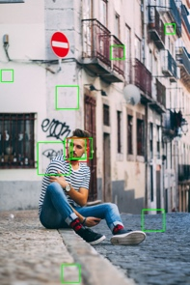

­



*1.2 TPR, F1-SCORE and Performance*

The TPR of the Object Detector is extremely good as it recognized every face, excluding the face in the left of the NoEntry7 image.

|  |  |  |  |  |  |  |
| --- | --- | --- | --- | --- | --- | --- |
| Image | NoEntry1 | NoEntry2 | NoEntry4 | NoEntry5 | NoEntry7 | NoEntry11 |
| TPR | 1 | 1 | 1 | 1 | 0.5 | 1 |

1.2.1 The problem on assessing the TPR in a meaningful way is that it is hard to define what a true positive really is. For example, the face in NoEntry7 can be considered too small, or that it is composed of too few pixels to be a face. In that case the TPR of the Object Detector would be 1.

1.2.2 It is easy to achieve a TPR of 100% on any detection task, as the algorithm can just detect all parts of the image as being a face. This would grant a 100% TPR, although it will also detect all the non-faces parts of the image as being a face (which does not contribute with much in deciding what is a face and what is not).

1.2.3 The F1 score is a much better way of assessing a detection algorithm, as it takes into consideration both TPR, FPR and FNR. And as we can see the face detector is not doing such great of a job, just because most of the faces that it detects are actually not faces.

|  |  |  |  |  |  |  |
| --- | --- | --- | --- | --- | --- | --- |
| Image | NoEntry1 | NoEntry2 | NoEntry4 | NoEntry5 | NoEntry7 | NoEntry11 |
| F1 | 0.2 | 0.13 | 0.06 | 0.33 | 0.22 | 0.18 |

**Subtask 2: No Entry Sign Detector**

*2.1 TPR vs FPR during training*

We can see that during the all three phases for training the TPR remains at 1, which means that the detector can see all the No Entry Signs. In the first stage (0-stage) the detector also seems to detected everything as being a No Entry Sign, thus the 1 FPR. In "1-stage" this effect is strongly reduced (from 1 to 0.015). On the third stage, the False Positive Rate is close to 0, this meaning that the detector now does a much better job at identifying which images or parts of images are and are not a No Entry Sign.

*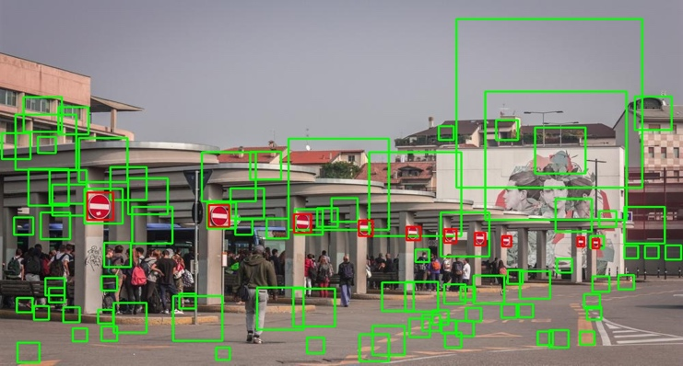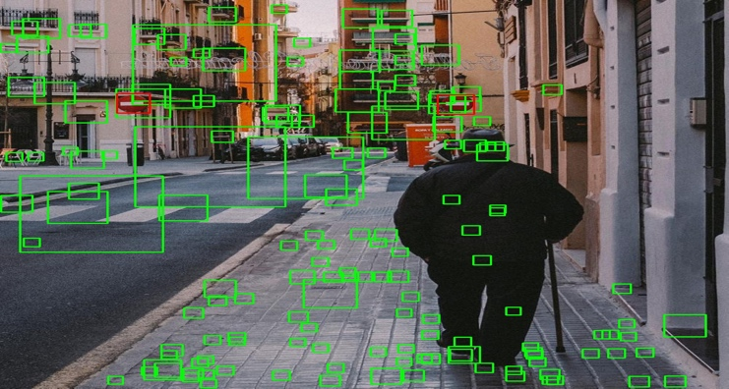2.2 Testing performance*

|  |  |  |
| --- | --- | --- |
|  | *TPR* | *F1* |
| *NoEntry0.bmp* | *1* | *0.025* |
| *NoEntry1.bmp* | *1* | *0.022* |
| *NoEntry2.bmp* | *1* | *0.016* |
| *NoEntry3.bmp* | *1* | *0.015* |
| *NoEntry4.bmp* | *1* | *0.026* |
| *NoEntry5.bmp* | *0.4* | *0.084* |
| *NoEntry6.bmp* | *0.75* | *0.107* |
| *NoEntry7.bmp* | *1* | *0.021* |
| *NoEntry8.bmp* | *1* | *0.216* |
| *NoEntry9.bmp* | *1* | *0.037* |
| *NoEntry10.bmp* | *0.5* | *0.117* |
| *NoEntry11.bmp* | *0.66* | *0.02* |
| *NoEntry12.bmp* | *0.5* | *0.108* |
| *NoEntry13.bmp* | *0.71* | *0* |
| *NoEntry14.bmp* | *0* | *0.037* |
| *NoEntry15.bmp* | *1* | *0.235* |
| *Overall* | *0.78* | *0.076* |

As we can see the true positive rate is close to what we should expect, seeing the results during training. But, looking at the output images and the F1 score, we can see that the False Positive Rate is far bigger than the training algorithm suggests. That means that our detector is now great at finding No Entry Signs, but not as great at filtering them.

**Subtask 3: Integration with Shape Detectors**

*3.1 Hough Details*

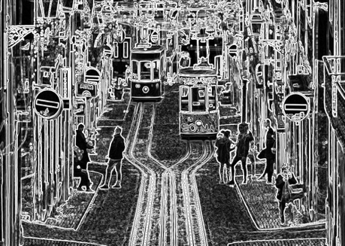

**

|  |  |  |  |  |
| --- | --- | --- | --- | --- |
|  | TPR | F1 | *TPR Difference to Viola-Jones* | *F1 Difference to Viola-Jones* |
| NoEntry0.bmp | 0 | 0 | *1* | *-0.025* |
| NoEntry1.bmp | 1 | 1 | *0* | *0.978* |
| NoEntry2.bmp | 1 | 0.666 | *0* | *0.65* |
| NoEntry3.bmp | 1 | 0.571 | *0* | *0.556* |
| NoEntry4.bmp | 1 | 1 | *0* | *0.974* |
| NoEntry5.bmp | 0.1 | 0.181 | *-0.3* | *0.097* |
| NoEntry6.bmp | 0.75 | 0.352 | *0* | *0.245* |
| NoEntry7.bmp | 0 | 0 | *-1* | *-0.021* |
| NoEntry8.bmp | 1 | 1 | *0* | *0.784* |
| NoEntry9.bmp | 0.5 | 0.666 | *-0.5* | *0.629* |
| NoEntry10.bmp | 0.666 | 0.666 | *0.166* | *0.549* |
| NoEntry11.bmp | 0.5 | 0.666 | *0.166* | *0.646* |
| NoEntry12.bmp | 0.428 | 0.6 | *-0.072* | *0.492* |
| NoEntry13.bmp | 0 | 0 | *-0.71* | *0* |
| NoEntry14.bmp | 1 | 1 | *1* | *0.963* |
| NoEntry15.bmp | 1 | 1 | *0* | *0.765* |
| Overall | 0.621 | 0.585 | *-0.159* | *0.509* |

*3.2 Evaluation*

As we can see from both the table and the images, the F1 score is significantly better.

From the photos we can easily see that the Hough transformation for circles is giving us a really good estimation for where circles are, and more important, where they are not.

We can see that in the first set of images we now only recognize 3 No Entry Signs, whilst with only Viola-Jones we were detecting way to many. This did bring down our TPR by a bit, but greatly increased the F1 Score.

This is the case most of the time, the conclusion being that the integration with shape detectors improves mostly the accuracy.

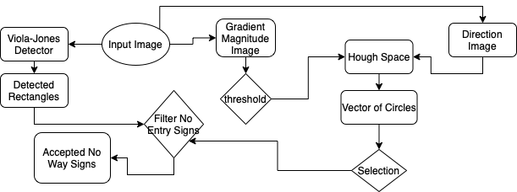The program computes the Gradient Magnitude Image (and applies a basic threshold function on it) and the Direction Image. Both of them are used in the

Creation of the Hough Space, which grants us with a vector of circles. They go onto a selection process, to make sure that we are only taking into consideration circles that can be No Way Signs.

On the other side we are building a Detected Rectangles vector using Viola-Jones. This and the vector of circles are then going into a filter. The rectangles that are left after the filtering are the Accepted No Way Signs.